**Stduio 7**

**Exercise1:** Qitao Xu, Jiangnan Liu, Zhe Wang

**Exercise2**:

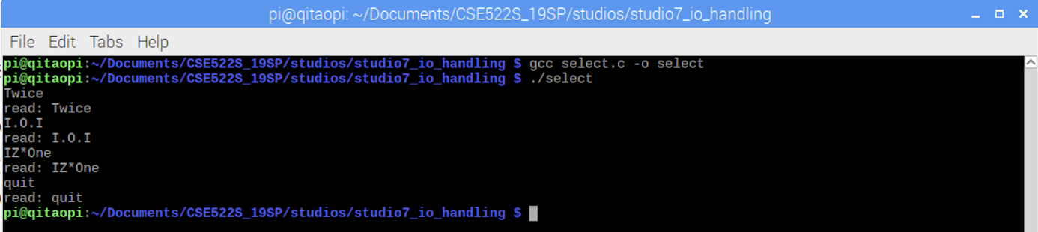

**Exercise3**:

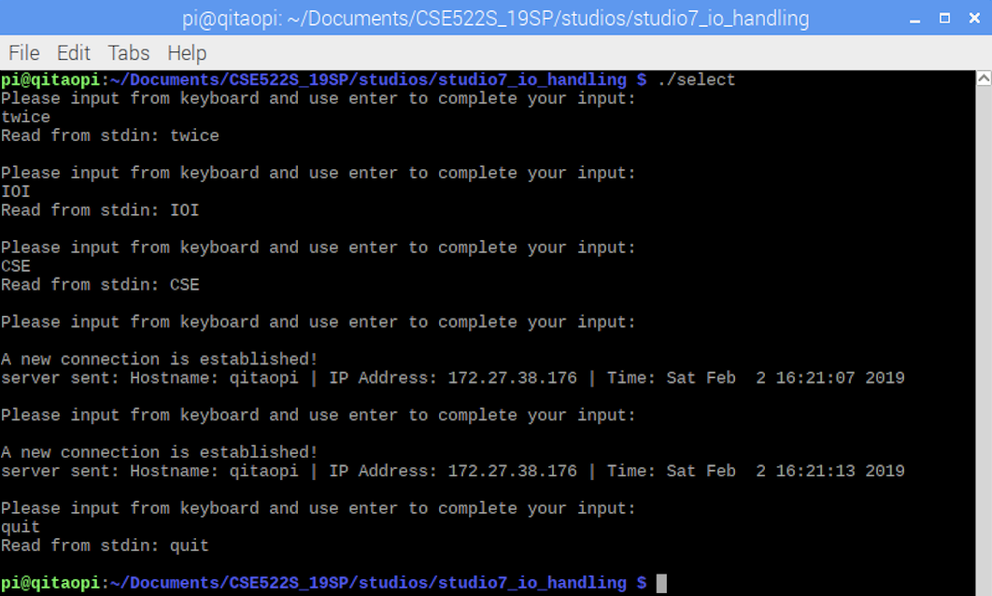

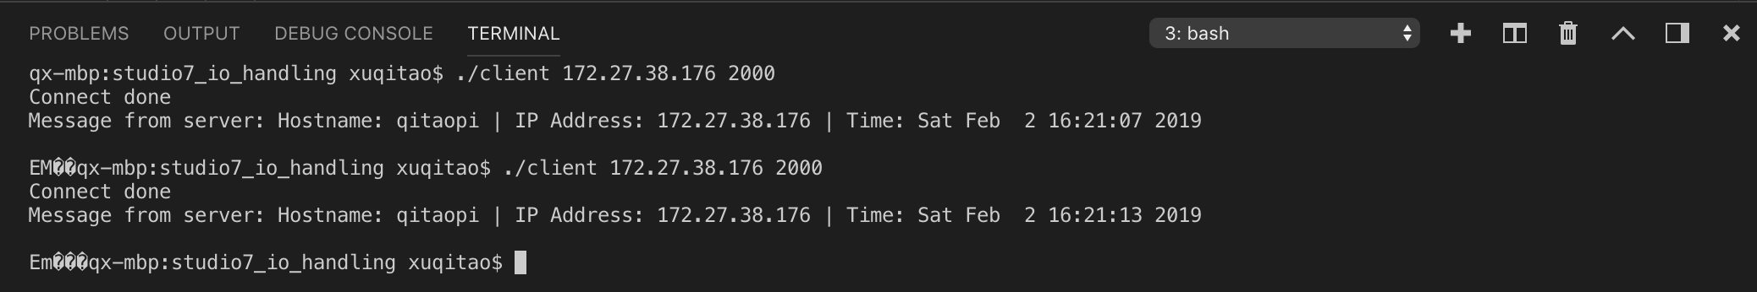

**Exercise4**:

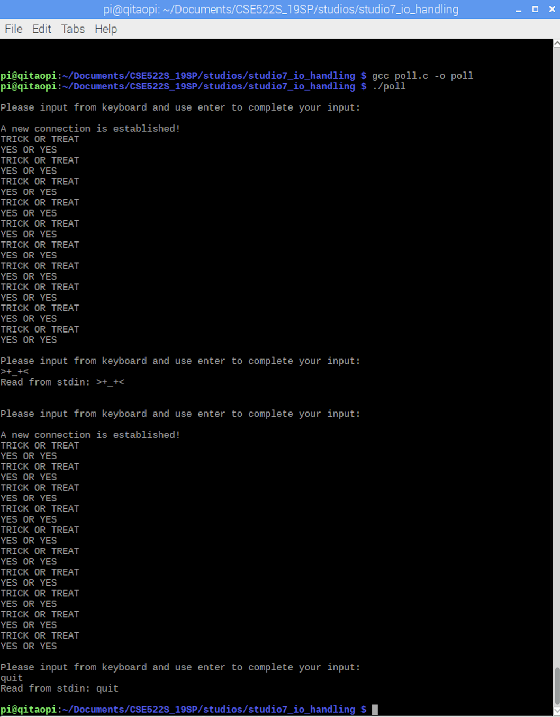

**Exercise5**:

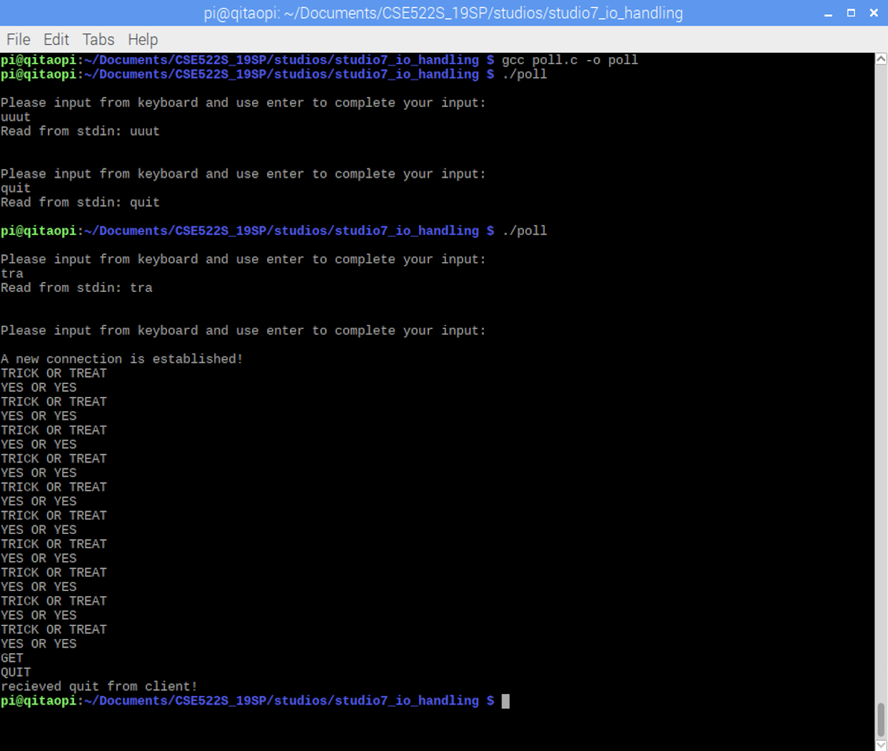

**Exercise6**: